**ZimBuilds: AI-Enhanced Web Platform for Streamlined Residential Plan Approvals in Urban Development**

Ropafadzo E Munetsi; Kenneth Chiworera

*Department of Software Engineering, School of Information Sciences and Technology, Harare Institute of Technology, Harare, Zimbabwe*

[esalenciar@gmail.com](mailto:esalenciar@gmail.com) ; [kchiworera@hit.ac.zw](mailto:kchiworera@hit.ac.zw)

**Abstract—Rapid urbanization in Zimbabwe, as of 2012, has created problems for the local council authorities, creating a highly flawed manual and time-consuming system, causing delays in the residential plan approval process, hence the administrative burden on local council authorities. This paper presents an innovative web-based residential plan approval system that utilizes AI-based compliance checking, automation, and centralized documentation storage to solve these problems. ZimBuilds is a comprehensive solution that deals with document uploading, plan review, inspection scheduling, and payment. It includes a web interface for inspectors, administrators, and applicants, aiming for transparency and application tracking.**

1. INTRODUCTION

Zimbabwe's urbanization has been motivated by economic development, population increase, and rural-urban migration in the past two decades. As a result, there is a high demand for residential buildings, which necessitates the prompt approval of building plans by municipalities. However, the approval of residential plans is still largely manual and paper-driven.

The local authorities require applicants to submit physical architectural plans, structural plans, and documents to various departments, like engineering, planning, and health, to check them for compliance, which is tedious and time-consuming. Making the switch to a digital platform will expedite the application process, lower error rates, and give applicants and city council staff real-time updates. Adopting technology would increase overall consumer happiness in addition to efficiency. And the primary objectives of my proposed solution are to:

1. To digitize and streamline the workflow of residential plan application and its approval.
2. To use AI-based document verification for automatic compliance checking.
3. To automate the scheduling and monitoring of inspections.
4. PROBLEM-STATEMENT

The current Zimbabwean residential plan approval procedure in the local authorities is outdated, inefficient, and unable to cater to growing demand. This system's manual nature brings about the following primary concerns:

* Long periods taken to process an application.
* Lack of transparency and feedback to the applicant.
* Human errors and miscommunication.
* Difficulties in tracking applications and inspections.

1. RELATED WORK

In recent years quite several countries have tried to implement systems that streamline plan approval, for instance, the Online Building Plan Approval System of India. In [1] author explores the OBPAS, whichis making waves throughout several Indian states that have changed urban planning by digitalizing the entire building permit submission and approval process. OBPAS incorporates features of the Smart Digital Construction Review (SmartDCR) to automate compliance checks against building bylaws that minimize human error, increase efficiency, and decrease approval lag time. A case study by [1] on the implementation of OBPAS in Odisha indicates that OBPAS increased transparency and improved approval times, as low as 7 days, and limits steps that require in-person visits to government facilities, Dheeraj Mandloi et al, 2015. This represents an entirely different approach from cumbersome old paper systems that were prone to corruption, delays, and the archaic process of referencing building bylaws. There are possibilities for real-time interactions of architects and municipal officials in a collaborative system using OBPAS’s workflow engine and document validation capabilities.

Reyes-Carranza et al. in [2] provide insight into the generation and outcome of Ke DAMS (Kajiado’s e-Development Management System) of Nairobi, Kenya. Ke DAMS is a web-based portal developed in 2020 that automates the issuance of building permits by digitalizing the process of issuing construction permits in the construction industry, making it transparent and user-friendly. The author in [2] sees Ke DAMS as an initiative to fight corruption, which is ushering in a new digital age of local governance regarding the regulation of this sector. Although the action to electronically permit development is a step towards improvement, Reyes-Carranza et al. in [2] point out limitations, such as when systems are not specific to the unique context of peripheral or informal areas, which still tend to be the focus of centralized systems. Improvements can be realized by the industry, everyone in procedures such as those in both building inspection and construction approval, when implemented, not only automated but also contextual approaches in developing and integrating structures into the processes. The example of Nairobi is a unique case of e-construction permit systems that exploit the early stages of digital intervention into urban governance. However, Reyes-Carranza et al. argue that flexible, accessible, and appropriate digital solutions must account for the 'formal' and 'informal' practice of development in any analysis of the urban landscape.

According to an online publication by Saarda, in October 2021, the City of Johannesburg launched a web-based Construction Permit Management System to digitize the statutory submission of building plans, which was entirely based on a paper format and manual processes at various stages. The City of Johannesburg's Construction Permit Management System allows SACAP-registered architectural professionals to electronically submit building plans, reducing the reliance on physical documentation, which will also allow for faster processing of applications [5]. This constitutes part of the City of Johannesburg's Smart City program and aligns with the [5] City’s Growth and Development Strategy 2040 by improving transparency, operational efficiency, and service delivery. Some of the highlights of the system include: real-time updates, the ability to categorize types of buildings regarding the plans submitted, and to link inspection workstreams with the building plan management process. In [3][4], the expectation is that it will halve the decision turnaround time from 30 days to 15 days, assuming all submissions are complete. The online system provides another layer for fraud mitigation as it will be checking registration credentials.

To conclude, across the globe, we are starting to see widespread public acceptance of Artificial Intelligence (AI) integration in building plan approvals. In [6], an example is Estonia's 'Kratt' strategy that promotes the use of AI to automate administrative tasks, including document verification. As alluded to by the author in [6], AI systems may retain the ability to automatically check and review architectural documents to ensure compliance with relevant zoning laws and building codes; again, minimizing human error and accelerating the approval process.

1. THE SOLUTION
2. AI-Powered Document Compliance Verification: Uploaded architectural plans are immediately reviewed by AI against regulatory stipulations, which ensures prompt identification of compliance problems, reducing back-and-forth with applicants.
3. Online Application Submission: Applicants can submit building plans, company/personal information, and supporting documents via a web form, and role-based dashboards for admin, inspector, and applicants.
4. Automated Inspection Scheduling: Inspections are automatically assigned based on project stages. Inspectors can view, take, and report inspection results.

B. SOLUTION ARCHITECTURE

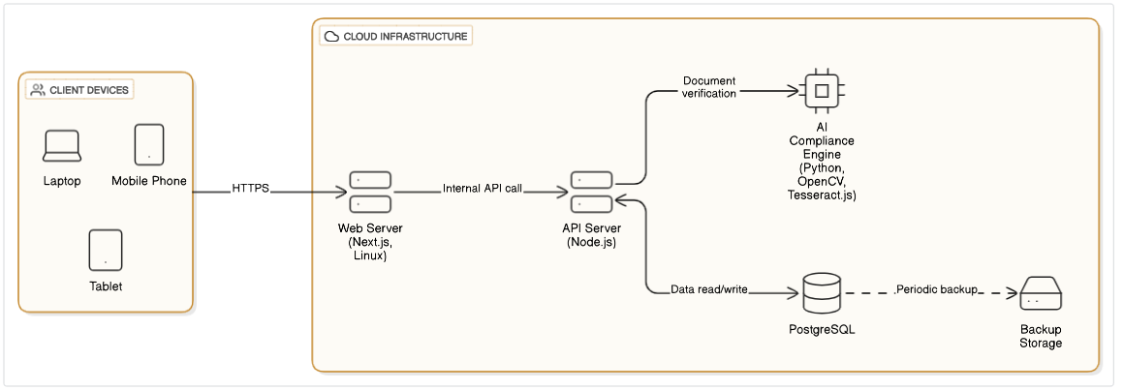

1. METHODOLOGY

The method used for requirements gathering was interviews with planning officers, architects and other stakeholders, and observation of municipal processes were carried out. Functional and non-functional requirements were then determined and documented. On system design, the system employs reusable and modular design patterns. All of the forms follow a consistent layout, based on the Plan Approval Form, with field validation and grouping. The use of Tailwind CSS enables responsive design, while icons and headers ensure intuitive navigation.

AI document verification uses pre-trained models and custom zoning rules to review image files or PDFs that have been uploaded. Missing items or defects (e.g., missing label, scale, or codes of safety) are marked for review.

In the development stage, Agile development was followed with sprints aimed at:

* UI/UX design.
* API and database integration.
* Document verification engine.
* Payment and inspection scheduling modules.

Version control was done through GitHub, and all APIs were tested using Postman before frontend integration.

1. RESULTS

Document Verification Accuracy: From a sample of 50 architectural plans created to meet standard local building codes:

* AI verification detected non-compliance in 42% of applications (e.g., missing zoning information, incorrect building heights).
* The system correctly identified missing elements with 91% accuracy, confirmed through manual cross-verification by inspectors.
* The average processing and return time for AI was under 45 seconds per document.

Application Turnaround Time: In contrast to the existing manual process, which takes 90+ days:

* Applications submitted through the system took on average 10–15 working days to process, if documents were complete.
* Feedback loops that were instantaneous allowed applicants to resubmit amended plans within a space of hours, significantly reducing delays.

Inspection Management

* Inspectors were assigned automatically by area and availability, and administrative workload was decreased by 70%.
* Real-time status updating allowed inspectors to report outcomes directly from the field via mobile devices.
* Scheduling conflicts for inspections were reduced to near zero, owing to the built-in calendar and conflict-checking logic.

Admin Portal for reports and analytics



|  |  |  |
| --- | --- | --- |
| Objective | Achieved | Partially Achieved |
| To develop a web app that streamlines the application process for plan approval | ✓ |  |
| To automate document verification using AI-powered document verification. | ✓ |  |
| To automate payment by integrating online payments | ✓ |  |
| To implement automated inspector appointment scheduling | ✓ |  |

1. CONCLUSION AND FUTURE

The e-approval of residential plans online revolutionizes the submission of building plans in Zimbabwe through computerization of submissions, incorporation of artificial intelligence verification, and providing open tracking. The system solves persistent problems related to delays in processing, inefficiency, and absence of proper feedback.

In future releases, the system can be enhanced by:

* Incorporating status updates through SMS/email notifications.
* Including support for 3D BIM model checking.
* Connecting to national land registries and GIS systems.
* Providing offline submission modules for low-connectivity regions.

1. BIOGRAPHY

**Ropafadzo Esalencia Munetsi** wasborn in Harare, Zimbabwe on 30 November 2001. Currently pursuing a degree in Software Engineering and a final year student at the Harare Institute of Technology in Harare, Zimbabwe.

REFERENCES

[1] M. Reyes-Carranza and D. Mbugua Muthama, “Urban sprawl and the automation of building control in the peripheries of Nairobi,” *Urban Geography*, 2025, doi: 10.1080/02723638.2025.2450307

[2] D. Mandloi and V. Thakur, “IJSR-INTERNATIONAL JOURNAL OF SCIENTIFIC RESEARCH,” 2013.

[3] N. B. C. Buthelezi, G. O. Onatu, and C. O. Aigbavboa, “Planning approval of housing developments: case study of the city of Johannesburg and Tshwane metropolitan municipalities of South Africa,” *Frontiers in Sustainable Cities*, vol. 7, Apr. 2025, doi: 10.3389/frsc.2025.1468965.

[4] H. Holmqvist and S. Papp, “A critical analysis of the building permit process at the Urban Planning Department in Gothenburg Identification of improvement measures for a smoother internal process Master’s Thesis in the Master’s Programme Design and Construction Project Management,” 2015.

[5] <https://www.saarda.co.za/> development-planning-launches-the-city-of-joburg-construction-permit-management-system

[6] K. Härmand, “AI Systems’ Impact on the Recognition of Foreign Judgements: The Case of Estonia,” *Juridica International*, vol. 32, pp. 107–118, Dec. 2023, doi: 10.12697/ji.2023.32.09.